1. Consider the following snapshot of a system:
Allocation Max Available
A B C D A B C D A B C D
P0 0 0 1 2 0 0 1 2 1 5 2 0
P1 1 0 0 0 1 7 5 0
P2 1 3 5 4 2 3 5 6
P3 0 6 3 2 0 6 5 2
P4 0 0 1 4 0 6 5 6
- Is the system in a safe state? Show the reason of your answer. (2 pts)

- Can the request be granted immediately, if a request from P0 arrives for (0,3,2,0)? (2 pts)

- Can the request be granted immediately, if a request from P1 arrives for (0,5,0,0)? (3 pts)

2. Compare the following three memory allocation methods, contiguous memory allocation, pure segmentation, and pure paging, in terms of the following issues:
a. External fragmentation (2pts)

b. Internal fragmentation (2pts)

c. Ability to share codes across processes (2pts)

3. The following figure depicts the life cycle of an I/O operation requested by a user process, from the request I/O step to the I/O completed step. Fill the blanks to complete the explanation of the life-cycle. (10pts)

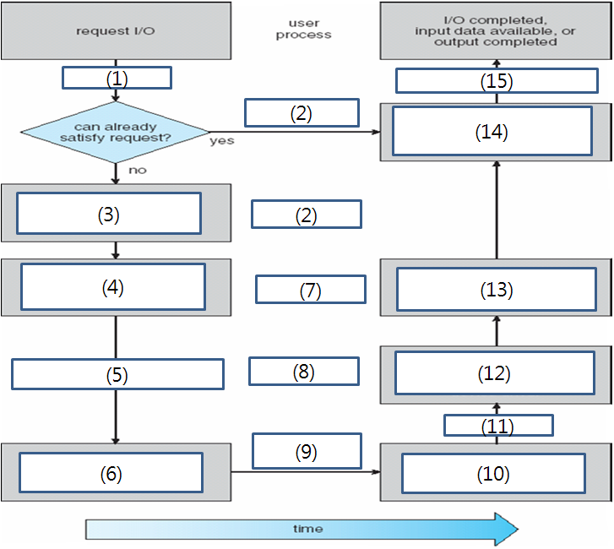
\

4. Why does a threshing occur? (3pts) How can an operating system detect a threshing? (2pts) How does an operating system handle a threshing when it is detected? (2pts)

5. What is buffering? (3pts) Show three reasons why buffering is used. (2pts) What is the difference of the buffering from caching? (2pts)

6. The following figure depicts the procedure of accessing memory by CPU in paging hardware with TLB. Fill up (1)~(10). (1pt each)
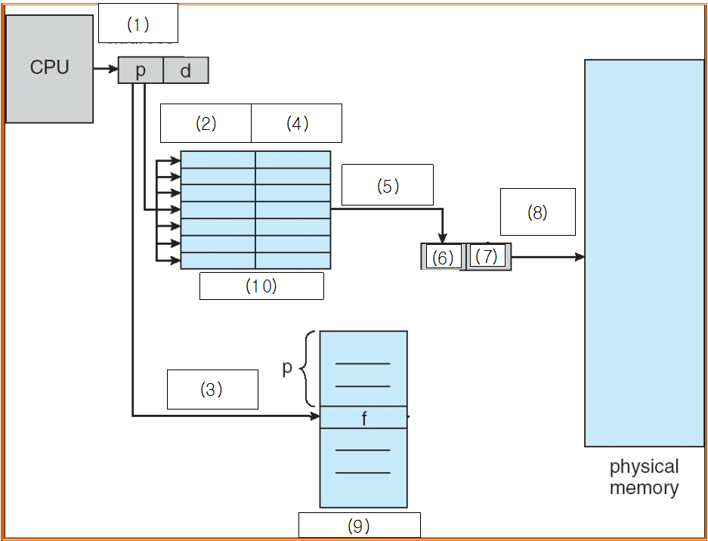

7. Explain blocking I/O (2pt), non-blocking I/O (2pt), and asynchronous I/O (2pt), respectively.

8. The following figure shows the procedure of handling a page fault event. Fill the blanks. (6pts)
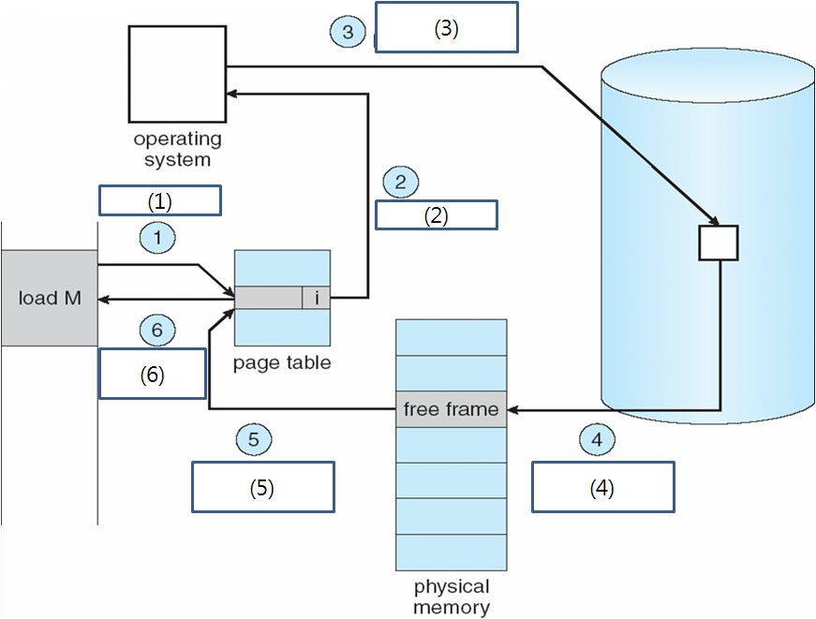

9. Explain FAT as in detail as possible. What is the advantage of FAT compared to the other methods you learned in the class? (8pts)

10. LRU method works very well as a page replacement algorithm. However, it is not used as it is. Explain why (4pts) and show the solution to handle the problem. (4pts)

11. Why does a modern operating system utilize a virtual memory system? Show the reason. (7pts)

12. Consider the page table shown below for a system with 12-bit virtual and physical addresses and 256-byte pages. The list of free page frames is D, E, F (that is, D is at the head of the list, and F is last). Convert the following virtual addresses to their equivalent physical addresses in hexadecimal. All numbers are given in hexadecimal. (A dash for a page frame indicates that the page is not in memory.)
a. 5EF (2pts)
Page | Page Frame
0 | -
1 | A
2 | C
3 | 2
4 | -
5 | B
6 | 3
7 | -
8 | 4
9 | 0

b. 311 (2pts)

c. 013 (2pts)

d. 4AB (2pts)

13. Suppose the stack-based LRU is utilized and the number of frame pages is three, which is numbered 1~3, respectively. On the following sequence of the page references, show the state of the stack at every page reference including the page # that is assigned to each page frame. (7pts)

Page reference sequence: 1 3 2 6 4 5 2 1 5 4 1 2 3 1 3

14. The following figure depicts the life cycle of an I/O operation requested by a user process, from the request I/O step to the I/O completed step. Fill the blanks to complete the explanation of the life-cycle. (7 pts)
